Emergency Response Plan
Contents
Purpose 1
Scope 2
Responsibilities 2
Supervisors 2
Workers 2
Safety Offices 2
Emergency Guidebook 3
Emergency Codes for Hospital-Hosted Locations 3
Accidents and Incidents 4
Post Emergency Inventory Check 4
Medical Emergencies 4
Fire 4
Chemical Spills 5
Biological Spills 5
Power Failure 5
Failure of Primary Containment Devices 5
Loss of Containment 6
Emergency Egress 6
Notification of Key Personnel 6
Natural Disasters and Human Caused Disasters 6
Incident Follow-up and Recommendations to Mitigate Future Risks 6
Training 6

Purpose
<<<< This SOP is left in DOCX format so that you may edit it for your own laboratory. YOU MUST EDIT THIS SOP>>>
The purpose of this SOP is to lay out the responsibilities and procedures required for emergency response.

Scope
This SOP applies to all laboratory occupants and their Supervisors.

Responsibilities

Supervisors
Supervisors are responsible for:
- Reviewing this SOP on a regular basis. Review is to consider and mitigate the risks of spill, loss of containment and exposure or other harm. Refer to Performing Risk Assessments SOP.
- Ensuring that all workers under their supervision are trained on and are proficient in performing the steps of this SOP.

Workers
Workers are responsible for:
- Following this SOP as approved by their supervisor

Safety Offices
There are four safety offices for McMaster University:
- Environmental and Occupational Health Support Services, EOHSS
  - Serves all faculties except the Faculty of Health Sciences
  - Occupational health and safety, excluding radioisotopes and biohazards
  - eohss@mcmaster.ca
  - http://www.workingatmcmaster.ca/eohss
- Faculty of Health Sciences Safety Office
  - Serves only the Faculty of Health Sciences
  - Occupational health and safety, excluding radioisotopes and biohazards
  - fhsso@mcmaster.ca
  - http://fhs.mcmaster.ca/safetyoffice
- Health Physics Department
  - Serves all faculties
  - Management of radioisotopes
  - hphys@mcmaster.ca
  - http://www.mcmaster.ca/healthphysics/index.html
- McMaster Biosafety Office
  - Serves all faculties
  - Management of biohazards
  - robertjv@mcmaster.ca
  - https://biosafety.mcmaster.ca

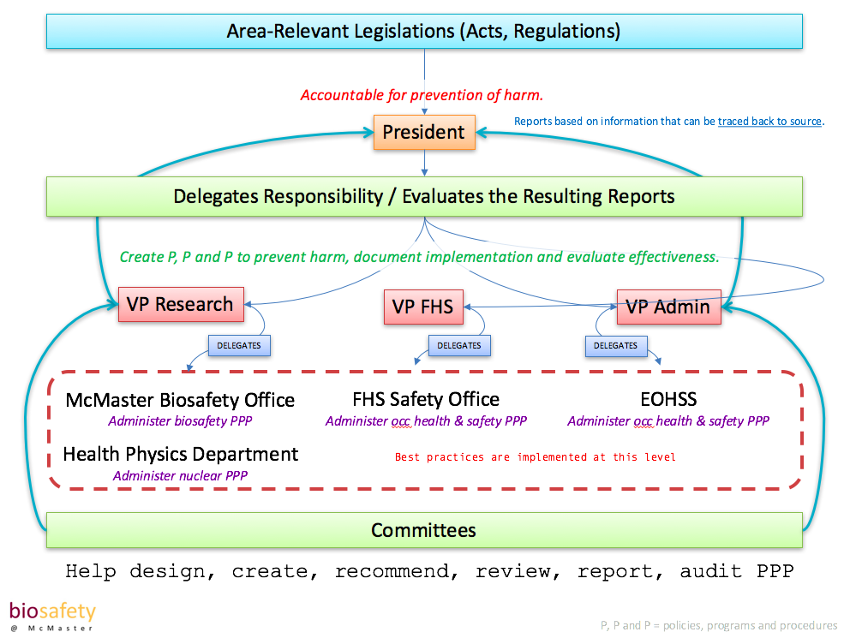

Emergency Guidebook
- All laboratory occupants and all Supervisors must read and familiarize themselves with the Emergency Guidebook, particularly emergency contact numbers and locations.
- http://security.mcmaster.ca/campus_emergencies_guide.html
- If there is information that you require, that is not in the emergency guidebook, please contact your Departmental Chair or Area Manager for information.
- Add required information to this SOP.

Emergency Codes for Hospital-Hosted Locations

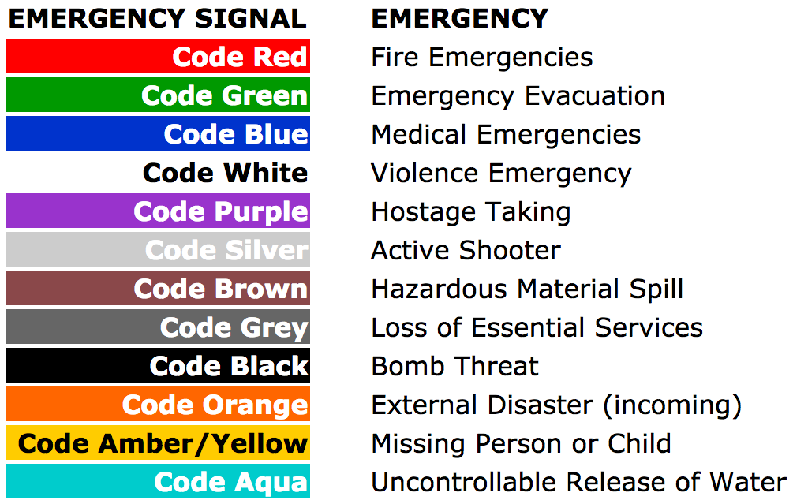

Accidents and Incidents
- All accidents and incidents must follow this same general procedure.
- Control the situation, prevent escalation of danger.
- Inform nearby occupants and Supervisor.
- Gather required information for a medical visit (MSDS or PSDS or similar).
- Seek medical attention if necessary.
- http://www.workingatmcmaster.ca/med/document/RMM-1000-Reporting-and-Investigating-Injury-Incident-Occupational-Disease-Program-1-36.pdf
- Fill an incident report. Signed by Supervisor. Signed by Dept Chair.
- Submit incident report to EOHSS (non-FHS) or FHS Safey Office (FHS).

Post Emergency Inventory Check
- When any emergency causes evacuation, upon re-entry to the building, all storage units of pathogens should be checked for integrity and theft of inventory items.
- Any damage or theft or suspicion of theft should be reported immediately to the Supervisor and to the Biosafety Office robertjv@mcmaster.ca x23453

Medical Emergencies
- See Emergency Guidebook for location-specific information.
- http://security.mcmaster.ca/campus_emergencies_guide.html

Fire
- All laboratory occupants are to participate in Fire Safety training on Mosaic, which is appropriate to their work environment.
- http://mosaic.mcmaster.ca
- Fire safety procedures are DIFFERENT in hospitals versus non-hospital hosted locations. Some may require non-hospital hosted training, others may require hospital-hosted training and some may require both.
- Annual updates may be required.
- Collect and update training records annually.

Chemical Spills
- All persons using chemicals are to participate in Chemical Handling and Spills training through Mosaic.
- http://mosaic.mcmaster.ca
- https://fhs.mcmaster.ca/safetyoffice/documents/UniversalPrecautionsandChemicalSpillpage.pdf
- http://cll.mcmaster.ca/eohss/chemhandlingspills.htm
- http://www.workingatmcmaster.ca/med/document/Lab-Safety-Handbook-1-36.pdf
- Collect and update training records annually.

Biological Spills
- All persons using biohazards must participate in Biosafety training through Mosaic and obtain related, practical training within their laboratory.
- http://mosaic.mcmaster.ca
- Biosafety spill protocols should be contained within their laboratory’s biosafety manual and should be signed off by all lab occupants.

Power Failure
- In the event of a power failure that affects primary containment devices follow the procedure below.
- In the event of a power failure, emergency power is supplied.
- Stop work, stand by and wait for instructions from your Supervisor.

Failure of Primary Containment Devices
- Failure of a BSC would be demonstrated by loss of power, alarming, sudden change in magnehelic readings or any sound or vibration that would indicate a malfunction.
- The following steps are the same if the BSC can remain on or if it must be turned off. They key is to close all containers as soon as possible.
- Stop all work.
- Close all sample containers.
- Spray out all sample containers.
- Decontaminate all surfaces.
- Collect all waste into waste bag.
- Change gloves.
- Close waste bag and spray all surfaces.
- Spray gloves and leave them in BSC.
- Wait minimum contact time for decontamination solution.
- Turn off BSC.
- Discard gloves in regular waste.
- Transport bagged waste to biohazard waste box or bin.
- Wash hands.
- Sign the BSC as out of order.
- Report the malfunction immediately to your Supervisor.

Loss of Containment
- Loss of containment constitutes a spill and should be dealt with according to the type of spill encountered. Spill SOPs are found where in your laboratory? SOP #?
- Loss of containment may also constitute an exposure and should be dealt with according to exposure protocols. Exposure protocols are found were in your laboratory? SOP#?

Emergency Egress
- Emergency egress is the path you take to evacuate your laboratory.
- Where is your laboratory’s ‘meeting place’?
- How do you get to your meeting place?

Notification of Key Personnel
- Personnel to be notified in emergencies should be included in each emergency SOP.
- Supervisor’s name, extension and emergency #

Natural Disasters and Human Caused Disasters
- These disasters are captured in the Crisis Management Response Plan.
- http://www.workingatmcmaster.ca/med/document/RMM-1200-Crisis-Management-Response-Plan-1-36.pdf

Incident Follow-up and Recommendations to Mitigate Future Risks
- All incidents are to be reported according to RMM1000. Ensure a copy of RMM1000 is printed and in your laboratory biosafety manual.
- http://www.workingatmcmaster.ca/med/document/RMM-1000-Reporting-and-Investigating-Injury-Incident-Occupational-Disease-Program-1-36.pdf
- Accident followup instructions are found in RMM1000 and include:
  - Scene assessment
  - Interviewing
  - Identify contributing factors
  - Make recommendations for corrective actions
  - Ensure recommendations are completed

Training
- Ensure all lab members have read and understood this SOP.
- Record dates and signatures of training.
- Follow your lab protocol for in-house training i.e. what signatures are required.
- If this SOP is updated, all persons require to be re-trained and re-sign.

