Pipetting

Contents

Purpose 1

Scope 1

Definitions 2

Responsibilities 2

Supervisors 2

Workers 2

Materials 3

General Safety Measures  4

Reducing Aerosols & Good Pipetting (see appendix 1) 4

Ergonomic Guidelines (see appendix 2) 4

Internal or External Contamination 5

Operational Procedure 5

References 5

Appendix 1 – Aspirating and Dispensing 6

Appendix 2 - Ergonomics of Pipetting 7

Appendix 3 – Pipettor diagram (Gilson shown) 8

Appendix 4 – Aerosol generation & prevention using filter tips 8

Appendix 5 - Pipet-Aid® Dual Pump Filtration Unit & Original Portable Pipet-Aid® Pipette Controller 9

# Purpose

<<<< This SOP is left in DOCX format so that you may edit it for your own laboratory>>>

The purpose of this SOP is to lay out the responsibilities, equipment and procedures required for using a pipet aid.

# Scope

This SOP applies to all persons prescribing and requiring using a pipettor or a pipet aid.

# Definitions

**Aspirate** – to draw the liquid up into the pipette tip

**Dispense** – to discharge the liquid from the tip

**Calibration check** – to check the difference between the dispensed liquid and the selected volume **Adjustment** – altering the pipette settings so that the dispensed volume is within the specifications

**BSC** – Biological Safety Cabinet

Types of Pipet aids and pipettman can be viewed at:

<https://www.youtube.com/watch?v=SAGtGk1iTYo>

At the bench on line link <http://www.colorado.edu/outreach/BSI/pdfs/AtTheBench.pdf> provides some good laboratory practices tips.

Other resources including Good Microbiological Technique: <https://biosafety.mcmaster.ca/biosafety_links.htm>

# Responsibilities

## Supervisors

Supervisors are responsible for:

* **Reviewing this SOP on a regular basis. Review is to consider and mitigate the risks of spill, loss of containment and exposure or other harm. Refer to Performing Risk Assessments SOP.**
* Ensuring that all workers under their supervision are trained on and are proficient in performing the steps of this SOP.
* Ensuring all equipment used for liquid handling are in good repair, calibrated and decontaminated prior to repair/calibration.

## Workers

Workers are responsible for:

* Completing all training required for safe operation prior to first use.
* Following this SOP as approved by their supervisor
* Take proper care of equipment according to specified use guidelines as set out by the manufacturer.
* Reporting any broken equipment immediately to their supervisor

# Materials

* Choose appropriate pipettor, pipet, or pipet aid for the volume and the type of work; review your protocol for the work being undertaken. (see figure 1.0 for different types of pipets, pipet aids and pipettors)
* Choose the appropriate tips, or pipets for the type of pipet aid to be used, and that is chemically compatible with the reagents used. (e.g.; using glass pipets is preferred when dispensing organic solvents). Tips can be filtered or unfiltered.
*  Chemical compatibility chart can be found at: <https://tools.thermofisher.com/content/sfs/brochures/D20480.pdf>
* Waste container that is chemically compatible for liquids
* Waste container for solids (and disposable puncture proof container for disposable tips, serological pipettes etc.)
* Container with appropriate disinfectant for soiled re-useable serological/volumetric pipettes
* Appropriate disinfecting agent for the biological material to be used.

Wear the appropriate PPE for the materials you are handling (lab coat, gloves, eye protection etc.).

Figure 1.0 – Types of pipettors, pipets, pipet aids Key: (1) bulb (pipet filler), (2) pipet-aid, (3) pipet pump, (4) multichannel pipettor, (5) repeater pipettor, (6) capillary pipet with bulb, (7) transfer pipet, (8) volumetric pipet, (9) measuring pipet, (10) pipettor, (11) Pasteur pipet, bulb for Pasteur pipet.

(reprinted from At the Bench: A Laboratory Navigator)[1]

# General Safety Measures

Pipetting safety and following sterile technique will reduce the generation of aerosols. Follow the manufacturer’s guidelines for the device(s) you are using. A good reference for safety measures can be found at Artel: <http://www.artel-usa.com/pipette-use-safety-going-beyond-ergonomics-potential-risks/>

* Always work in the appropriate area, Biosafety cabinet, fume hood, etc, for the materials you using
* **NEVER MOUTH PIPET**
* Always use caution when attaching a tip or pipet (especially glass) to a pipet aid
* Never hold your pipet aid, pipettor upside down when a used pipet/tip is in place

## Reducing Aerosols & Good Pipetting (see appendix 1)

* Do not depress plunger while tip is immersed in the liquid (see Appendix 1); this causes bubbling of the liquid and can generate aerosols
* Do not forcefully aspirate (draw up liquid) or let go of the plunger while aspirating. This can result in contamination of interior and/or filter of your pipet aid or pipettor contributing to inaccurate measurements and cause cross contamination. Liquids drawn up beyond the pipet capacity or through the filter can become aerosolized. (see aspirating and dispensing of liquids Appendix 1)
* Never forcefully dispense liquids out or let go of micropipette plunger, bulb or other pipet aid devices during dispensing as this can aerosolize your liquids or cause splashing or spilling of hazardous material.
* Do not immerse the tip into liquid while dispensing liquid; this can cause bubbling, generating aerosols
* Do not forcefully eject tips; eject tips carefully into proper used tip container
* Remove serological pipettes from pipet aid carefully, to prevent splashing of liquid remaining in the tip
* Hold pipet aid, or pipettor in a vertical position during aspiration; helps to prevent inaccurate measurements.
* Dispose of all waste solutions according to RMM 502

## Ergonomic Guidelines (see appendix 2)

* Maintain good posture when standing or seated at the bench; ensure you are working at a comfortable height.
* Take regular breaks, as pipetting over a long period (including ejection of tips) can cause a repetitive strain injury
* Stretch arms and rotate wrists frequently during long periods of pipetting.
* Set up your materials (tips, reagents, disposal container etc.) so they are within your working space; Follow PHAC BSC Safe Use and Operation Guidelines and **Do not over-reach. Avoid twisting movements** as this can cause a back, hip or arm injury.
* Avoid resting elbows on bench, or on BSC grille; this can cause joint damage
* Never force a glass pipette on the pipet device. The glass can break or fragment creating the potential for a cut injury

# Internal or External Contamination

* Never remove the contaminated pipettor, or pipet aid from the BSC
* If liquids have been drawn up into the pipettor or pipet aid, dispose of drawn sample into liquid waste container, dispose tip into appropriate container, and proceed according to manufacturer’s directions on how to decontaminate your pipettor/pipet aid. Some pipettors or pipet aids may be disassembled, and various parts autoclaved. Follow the guidelines for your equipment.
* Recalibration of pipettor is necessary after disassembly and decontamination.

# Operational Procedure

* Determine the appropriate type of pipettor, or pipet aid for your protocol.
* If working with Risk Group 2 material, it is recommended to conduct work inside Biological safety cabinet.
* Follow guidelines for working inside a biological safety cabinet (work from clean to dirty)
* Pipettor racks will prevent placing the pipettor on the Biological safety cabinet work surface.
* Follow pipetting procedure as illustrated in appendix 1; vertical aspiration helps improve accuracy and reduce aerosols. Tilting the receiving vessel while dispensing liquids improves accuracy and reduces aerosols.
* Monitor pipet aid/pipettor accuracy monthly - calibration can be completed either in the lab or sent away to calibration company. Follow manufacturer’s recommendations.
* Eject/remove tips carefully into the waste container.
* When removing any device from the BSC, spray out of cabinet with appropriate disinfectant.

# References

[Canadian Biosafety Standards (CBS) 2nd Edition](http://canadianbiosafetystandards.collaboration.gc.ca/cbs-ncb/index-eng.php)

[McMaster University, Risk Management Manual: RMM 600 Biosafety](http://www.workingatmcmaster.ca/rmm/)

Pathogen Safety Data Sheets [and](http://www.phac-aspc.gc.ca/lab-bio/res/psds-ftss/index-eng.php) Risk Assessment

[Biosafety SOP-005 Transportation and Movement of Biohazards](https://biosafety.mcmaster.ca/biosafety_SOPs.htm)

[PHAC Spill Protocol](https://biosafety.mcmaster.ca/documents/doc105_phac_spill_procedures.pdf)

Risk Management Manual 102 OHSA

[Risk Management Manual 502](http://www.workingatmcmaster.ca/rmm/) Waste Management

[PHAC BSC Safe Use and Operation](https://biosafety.mcmaster.ca/documents/doc104_phac_bsc_safe_use.pdf)

# Appendix 1 – Aspirating and Dispensing

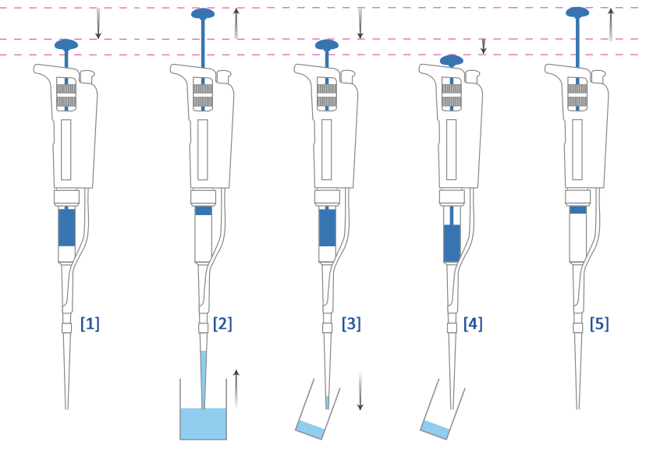

Taken from Gilson Principals of Pipetting video

* Always depress the plunger to the 1st stop prior to immersing the tip into liquid sample
* Always aspirate sample in the vertical position (see 2 above)
* Dispense sample while tube in held on a slight angle to prevent splashing of sample into tube. The tip should touch the side of the vessel while dispensing. (see 3 above)
* Do not immerse tip into liquid while dispensing (can create aerosols) (see 3 & 4 above)
* When dispensing, carefully depress the plunger to the 1st stop; pause, and then depress plunger to the 2nd stop to eject (blow-out) remaining liquid (see 3 and 4 above)
* Eject tip carefully into the proper waste container.

# Appendix 2 - Ergonomics of Pipetting



# Appendix 3 – Pipettor diagram (Gilson shown)[2]



# Appendix 4 – Aerosol generation & prevention using filter tips[3]

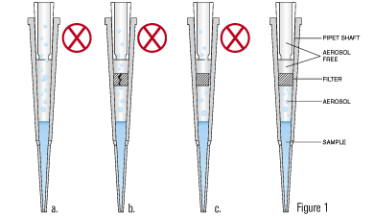

<https://www.matrixtechcorp.com/handheld/pipettor.aspx?id=38>

1. Non-filtered tip with aerosols reaching the pipet shaft
2. Damaged filtered tip, with aerosols reaching the pipet shaft
3. Filter does not properly fit in the tip, aerosols reach the pipet shaft
4. Properly fitted filter, blocking aerosols from the pipet shaft

# Appendix 5 - Pipet-Aid® Dual Pump Filtration Unit & Original Portable Pipet-Aid® Pipette Controller [4]

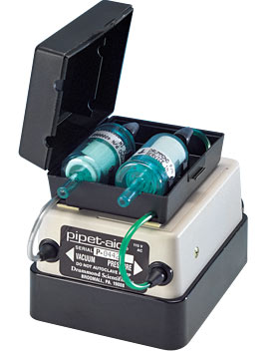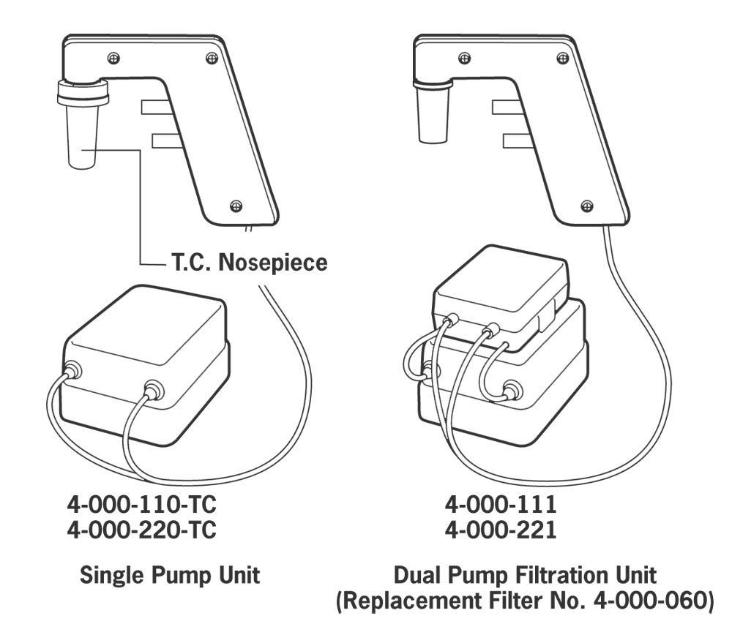

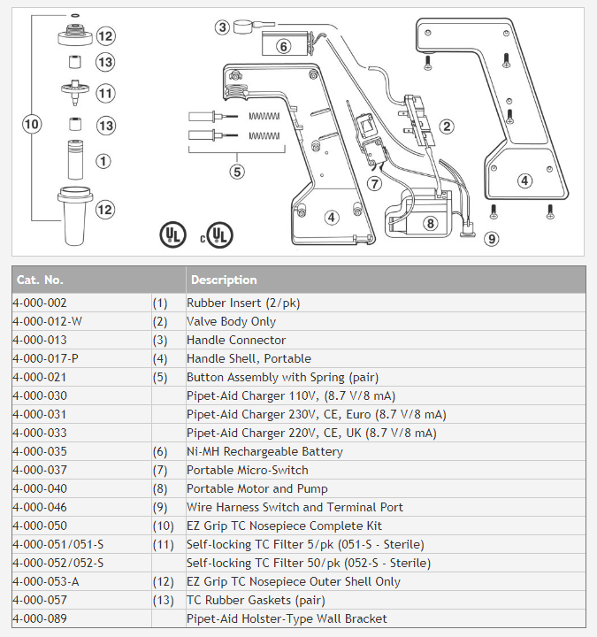

1. Barker, K. At the Bench: A Laboratory Navigator. New York: Cold Spring Harbor Press; c1998. Chp. 3, Figure 2; p. 52.
2. Taken from AccuTek Labs, Guide to pipetting
3. Taken from Thermo Scientific, Matrix Filter tips
4. Taken from Drummond Scientific Company <https://www.drummondsci.com/product.cfm?cat=pipet-aids&prod=pipet-aid-dual-pump-filtration-unit>