Two-Flask Aspirator System
Contents
Purpose 1
Scope 1
Responsibilities 1
Supervisors 1
Workers 2
Equipment Needed 2
Assembly 2
Pre-Use Check 3
Using the Aspirator 4
When You Are Done 4
Disassembly and Cleaning 4
SOP Training 5
Note About Why We Do Not Recommend Filling Overflow Flask With Disinfectant 5
References 6

Purpose
<<<< This SOP is left in DOCX format so that you may edit it for your own laboratory>>>
The purpose of this SOP is to lay out the responsibilities, equipment and procedures required for setup, use and maintenance of a two-flask aspirator system to be used with biohazardous liquids.

Scope
This SOP applies to all persons prescribing use and using a two-flask aspirator system to aspirate and decontaminate biohazardous liquids.

Responsibilities

Supervisors
Supervisors are responsible for:
- Reviewing this SOP on a regular basis. Review is to consider and mitigate the risks of spill, loss of containment and exposure or other harm. Refer to Performing Risk Assessments SOP.
- Providing the equipment required for use of a two-flask aspirator system if its use is prescribed by the Supervisor
- Replace or allow replacement of any broken equipment
- Ensuring that all workers under their supervision are trained on and are proficient in performing the step of this SOP.

Workers
Workers are responsible for:
- Following this SOP as approved by their supervisor
- Reporting any broken equipment immediately to their supervisor

Equipment Needed
- Poster provided at https://biosafety.mcmaster.ca/documents/doc180_aspirator_setup.pdf
- Two side-arm flasks – the size depends on frequency of use. Two-litre flasks are recommended.
- Two rubber stoppers with holes
- Two glass or plastic tubes long enough to extend ¾ down or more to the bottom of the flask
- One plastic bin that is large enough to hold the entire volume of the primary flask should it break
- Plastic hosing. Ensure that hosing is resistant to the chemical disinfectant in use.
- One In-line HEPA filter of pore size 0.2µm, write current date on filter with a Sharpie.
- One vacuum source
- One power-bar with a cord long enough to reach an outlet
- Zip ties to affix power bar to BSC front leg or 3M command hook and bull clip to hang it from the side
- 3M Command hook and bull clip to store your aspirator hose upright when not in use
- Biohazard labels
- Drierite dessicant
- WARNING: Some chemicals like phenol, chloroform, Trizol, acetone or xylene can melt plastic and are NOT to be used with aspirator systems. Instead these chemicals must be collected in a glass container and disposed as liquid chemical waste.

Assembly
- Plug powerbar into an appropriate outlet. If there is an available emergency outlet, use that.
- Affix the power bar to the front leg of the BSC using zip ties or clip cord near the bar with a bull clip and hang bar on a hook affixed to the side of the BSC. This keeps cords and the power bar off the floor.
- 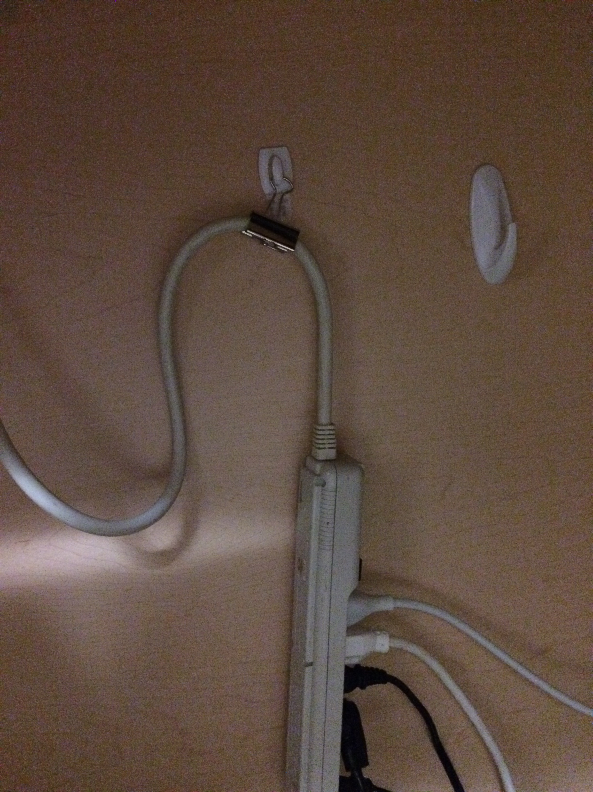
- Add Drierite to the overflow flask enough to cover the bottom of the flask. Drierite is the brand name and registered trademark of a variety of desiccants made from anhydrous calcium sulfate. Some varieties contain 3% cobalt (II) chloride, a moisture-sensitive color indicator that shows when that material’s activity has been depleted.
- https://secure.drierite.com/catalog3/default_home.cfm
- When the Drierite is pink; it is time to clean the system. It is not recommended to re-use the Drierite since a color change indicates that infectious aerosols were present. Treat the flask and Drierite as contaminated.
- Put the glass or plastic tubes through the rubber stoppers. If using glass, wear puncture resistant gloves.
- Put the rubber stoppers in the side-arm flasks. Ensure the tubes can almost reach the bottom of the flask. If the tube breaks and is shortened as a result, replace with a new, long tube. The reason the tubes are long, is so that the system is not short-circuited where liquids would be aspirated directly into the overflow flask.
- Place the flasks on the floor by the BSC.
- Ensure the primary flask is in a bin.
- Affix one tube from the side arm of the primary flask to the glass tube of the overflow flask.
- Affix one tube from the side-arm of overflow flask to an inline HEPA filter.
- Affix one tube from the inline HEPA filter to the vacuum source.
- Affix biohazard label to the primary flask.
- Draw a line ¾ of the volume of primary flask.
- Clip the end of the aspirator hose with a bull clip and hang on a 3M command hook affixed inside the BSC wall. This keeps any liquids left in the hose from dripping on the floor.

Pre-Use Check
- Check volume of waste in primary flask. If a risk of overflow is likely, disassemble and clean as described below.
- Ensure all hose connections are secure.
- Ensure power bar is secured.
- Ensure any slack hose or cord is secured.
- Ensure rubber stoppers are on tight.
- Verify HEPA filter is connected and does not appear to be wet or has changed in colour. Verify HEPA filter is changed at minimum, annually.
- Check oil level on vacuum. Follow manual for oil replacement.
- Ensure vacuum is not leaking oil.
- Inspect hose before affixing a Pasteur pipette. There may be glass shards present. Use forceps to remove shards and discard in sharps waste.

Using the Aspirator
- Turn on vacuum.
- Use a pedal if available.
- Affix Pasteur pipette to hose.
- Aspirate 1/10th of your expected waste volume of straight bleach into the primary flask.
- Discard pipette into sharps container.
- Secure aspirator hose when not in use.
- If you do not aspirate your expected waste volume, aspirate the balance volume of water to ensure the final solution of waste in the flask is 10% bleach total.

When You Are Done
- Aspirate 100ml of 10% bleach solution to disinfect the hose.
- Aspirate 100ml of tap water to rinse the bleach out of the hose.
- Remove and discard tip into sharps from aspirator hose.
- Secure aspirator hose.
- Complete cleanup of the BSC work area.

Disassembly and Cleaning
- If Drierite in the overflow flask is still BLUE
  - Aspirate 10% bleach into the primary flask until it just reaches beneath the side arm.
  - Stop the vacuum.
  - Remove the Pasteur pipette and discard into sharps waste.
  - Disconnect the tube from the side arm.
  - Carry the flask, rubber stopper, tube and hose to the sink carrying it slightly tilted to avoid spilling the bleachy solution.
  - Leave the flask in the sink for 30 minutes.
  - Decant the flask into the sink with lots of running water.
  - Disassemble and scrub with dish soap and water. Rinse. Reassemble system.
- If Drierite in the overflow flask is PINK (enough aerosols have come through the flask to change its colour)
  - Complete to step e above.
  - Using the hose, aspirate 10% bleach into the overflow flask until it just reaches beneath the side arm. The Drierite is still in the overflow flask.
  - Stop the vacuum.
  - Carry the overflow flask, rubber stopper, tube and hose to the sink, carrying it slightly tilted to avoid spilling the bleachy solution.
  - Leave the flask in the sink for 30 minutes.
  - Decant into a strainer, catching the Drierite with lots of running water. Discard bleached Drierite into regular waste.
  - Disassemble and scrub with dish soap and water. Rinse. DRY FLASK. Reassemble system.
  - HEPA filter goes into biohazard waste. Replace with new HEPA filter.

SOP Training
For a person to be deemed proficient in these procedures, the person must read the procedure, then watch the procedure and finally perform the procedure under supervision. The person supervising will then decide if further training is needed or if the person is proficient. The person supervising may be the Supervisor or his/her delegate. Once the person is deemed proficient, completion of training must be documented.

Note About Why We Do Not Recommend Filling Overflow Flask With Disinfectant
In image for aspirator setup, you will notice that the overflow flask is also filled with liquid. This liquid is disinfectant. The idea is to capture aerosols in the disinfectant so the aspirator is only vacuuming air that has been filtered through the disinfectant liquid. There are a number of reasons why we do NOT recommend this practice.
- The second flask cannot act as an overflow if it is already filled. If you forget about your primary flask when aspirating and your primary flask is overflowing, that 2L extra in the overflow flask is no longer available if it is filled in disinfectant. The disinfectant is now being aspirated into the vacuum system. Although it is only disinfectant, any liquid will damage a pump.
- We typically use bleach as a disinfectant, and 10% bleach has a short effective window once diluted. You would have to change the disinfectant in the overflow flask frequently to keep it fresh and effective.
- Having the overflow flask filled with bleach also means that you would double the amount of bleach poured into the sanitary sewer than is necessary.
By not keeping the overflow flask filled with disinfectant, we have given ourselves a window of safety when we have an overflow accident. We have also decreased the amount of attention that the overflow flask requires. However, if the tube in your primary flask is not submerged in disinfectant, aerosols are definitely captured in the overflow flask and HEPA filter. We have created a contaminated flask. To overcome this, when the HEPA filter requires changing, you can aspirate disinfectant into the overflow flask and let it sit prior to disassembly and cleaning.

References
Section 12.8 of the Canadian Biosafety Handbook - https://www.canada.ca/content/dam/phac-aspc/migration/cbsg-nldcb/cbh-gcb/assets/pdf/cbh-gcb-eng.pdf

